
Full Name: Chou Yamata
Location:  Phnom Penh | Current Title: Data Analyst  Email: chouyamata@gmail.com |  | Phone:  +855-10-411-311

About
A good starting database is MySQL + Spring Boot JPA with these main tables:
1. Core Database Structure
- users
- roles
- user_roles

- seller_requests
- stores

- categories
- brands

- products
- product_images
- product_specifications

- carts
- cart_items

- addresses
- orders
- order_items

- payments
- shipments

- product_reviews
- seller_reviews

- returns
- refunds

- notifications
- platform_settings

Main relationship
USER
│
├── USER_ROLES ── ROLE
│
├── SELLER_REQUEST
│ ↓
│ STORE
│ ↓
│ PRODUCTS
│ ├── PRODUCT_IMAGES
│ └── PRODUCT_SPECIFICATIONS
│
├── CART ── CART_ITEMS ── PRODUCT
│
├── ADDRESS
│
└── ORDERS
├── ORDER_ITEMS ── PRODUCT
├── PAYMENT
├── SHIPMENT
├── RETURN
└── REFUND

CATEGORY ── PRODUCTS
BRAND ───── PRODUCTS

PRODUCT ── PRODUCT_REVIEWS
STORE ──── SELLER_REVIEWS

2. users
Stores all registered users.
Column | Type | Description
id | BIGINT PK | User ID
username | VARCHAR(100) | Username
email | VARCHAR(150) UNIQUE | Email
password | VARCHAR(255) | BCrypt password
first_name | VARCHAR(100) | First name
last_name | VARCHAR(100) | Last name
phone | VARCHAR(30) | Phone
status | VARCHAR(30) | ACTIVE/BLOCKED
created_at | DATETIME | Created date

3. roles
You can start with:
ADMIN, STAFF, CUSTOMER, SELLER
id | name
1 | ADMIN
2 | STAFF
3 | CUSTOMER
4 | SELLER

Because one user can potentially have multiple roles, use a separate user_roles table.
user_roles
- user_id → users.id
- role_id → roles.id
Example:
- User A → CUSTOMER
- User A → SELLER
This fits your marketplace because a customer can later become an approved seller.
4. seller_requests
When a customer wants to become a seller:
- USER
- ↓
- seller_requests
- ↓
- ADMIN APPROVAL
- ↓
- SELLER
Column | Type
id | BIGINT PK
user_id | BIGINT PK
business_name | VARCHAR(150)
phone | VARCHAR(30)
address | TEXT
description | TEXT
status | VARCHAR(30)
rejection_reason | TEXT
reviewed_by | BIGINT PK
created_at | DATATIME
reviewed_at | DATATIME

Status:
- PENDING
- APPROVED
- REJECTED
- SUSPENDED

5. stores
After seller approval, the seller creates a store.
Column | Type
id | BIGINT PK
user_id | BIGINT FK → users.id
seller_id | VARCHAR(150)
logo | VARCHAR(255)
description | TEXT
phone | VARCHAR(30)
address | TEXT
status | VARCHAR(30)
created_at | DATETIME

Relationship:
- USER (Seller)
- │
- │1
- ↓
- STORE
- │
- │ 1:N
- ↓
- PRODUCTS

6. categories
Admin controls categories.
Column | Type
id | BIGINT PK
name | VARCHAR(100)
description | TEXT
status | VARCHAR(30)

Example:
- Computer
- CPU
- GPU
- RAM
- Motherboard
- SSD
- HDD
- PSU
- Case
- Monitor
- Keyboard
- Mouse
- Accessories
Again, sellers only select an existing brand.

7. brands
Admin controls brands.
Column | Type
id | BIGINT PK
name | VARCHAR(100)
logo | VARCHAR(255)
status | VARCHAR(30)

Example:
- Intel
- AMD
- NVIDIA
- ASUS
- MSI
- Gigabyte
- Corsair
- Kingston
- Samsung
- Western Digital
Again, sellers only select an existing brand.

8. products
This is one of your most important tables.
Column | Type
id | BIGINT PK
store_id | BIGINT PK
category_id | BIGINT PK
brand_id | BIGINT PK
name | VARCHAR(150)
description | TEXT
price | DECIMAL(12,2)
stock | INT
condition | VARCHAR(30)
warranty | VARCHAR(100)
status | VARCHAR(30)
approval_reason | TEXT
created_at | DATETIME
updated_at | DATETIME

Example:
- Store: ABC Computer
- Category: CPU
- Brand: AMD
- Name: Ryzen 7 7800X3D
- Price: $399
- Stock: 10

9. product_images
Don't put 8 image columns directly inside products.
❌ Don't do:
- image1
- image2
- image3
- ...
- image8
Instead:
- products
- ↓
- product_images
Column | Type
id | BIGINT PK
product_id | BIGINT PK
image_url | VARCHAR(500)
sort_order | INT
created_at | DATETIME

Then one product can have:
- Product 1
- ├── image 1
- ├── image 2
- ├── image 3
- ├── image 4
- └── ...
- └── image 8
The 8-image limit should be a platform setting/business rule, not eight columns.

10. Product Specifications
This part is important for your project because different computer categories have different specifications.
You have two common approaches.
Option A — Flexible specification tables
- specification_definitions
- product_specifications
specification_definitions
id | category_id | name
1 | CPU | Socket
2 | CPU | Cores
3 | CPU | Threads
4 | CPU | Base Clock
5 | CPU | Boost Clock
6 | RAM | Capacity
7 | RAM | DDR Type
8 | RAM | Speed

product_specifications
id | product_id | specification_id | value
1 | 100 | 1 | AM5
2 | 100 | 2 | 8
3 | 100 | 3 | 18
4 | 100 | 4 | 4.2 GHz

This allows your admin to define specifications per category.
For example:
- CPU
- ├── Socket
- ├── Cores
- ├── Threads
- ├── Base Clock
- └── Boost Clock
- RAM
- ├── Capacity
- ├── DDR Type
- ├── Speed
- └── Modules
For your marketplace, this is much more flexible than adding columns such as cpu_socket, ram_speed, etc. to the product table.

11. addresses
Customers need delivery addresses.
Column | Type
id | BIGINT PK
user_id | BIGINT FK
recipient_name | VARCHAR(150)
phone | VARCHAR(30)
province | VARCHAR(100)
district | VARCHAR(100)
commune | VARCHAR(100)
address_detail | TEXT
is_default | BOOLEAN

One user can have multiple addresses.
- USER
- ├── Address 1
- ├── Address 2
- └── Address 3

12. carts
Column | Type
id | BIGINT PK
user_id | BIGINT FK
created_at | DATETIME
updated_at | DATETIME

cart_items
Column | Type
id | BIGINT PK
cart_id | BIGINT FK
product_id | BIGINT FK
quantity | INT

Relationship:
- USER
- ↓
- CART
- ↓
- CART_ITEMS
- ↓
- PRODUCT

13. orders
Column | Type
id | BIGINT PK
user_id | BIGINT FK
address_id | BIGINT FK
order_number | VARCHAR(50) UNIQUE
subtotal | DECIMAL(12,2)
shipping_fee | DECIMAL(12,2)
total_amount | DECIMAL(12,2)
status | VARCHAR(30)
created_at | DATETIME

Order status:
- PLACED
- PAYMENT_CONFIRMED
- PROCESSING
- SHIPPED
- DELIVERED
- COMPLETED
- CANCELLED

14. order_items
This is important for a marketplace.
One order can contain products from different sellers.
Column | Type
id | BIGINT PK
order_id | BIGINT FK
product_id | BIGINT FK
store_id | BIGINT FK
product_name | VARCHAR(150)
price | DECIMAL(12,2)
quantity | INT
subtotal | DECIMAL(12,2)

For example:
- Order #1001
- ├── RTX 5070
- │ Seller A
- │
- ├── RAM 32GB
- │ Seller B
- │
- └── SSD 1TB Seller C
This is one of the differences between a normal computer store and a marketplace.

15. payments
Column | Type
id | BIGINT PK
order_id | BIGINT FK
payment_method | VARCHAR(50)
transaction_id | VARCHAR(255)
amount | DECIMAL(12,2)
status | VARCHAR(30)
paid_at | DATETIME

Example:
- PENDING
- PAID
- FAILED
- REFUNDED
16. shipments
Column | Type
id | BIGINT PK
order_id | BIGINT FK
shipping_method | VARCHAR(100)
tracking_number | VARCHAR(100)
status | VARCHAR(30)
shipped_at | DATETIME
delivered_at | DATETIME

17. product_reviews
Column | Type
id | BIGINT PK
product_id | BIGINT FK
user_id | BIGINT FK
order_item_id | BIGINT FK
rating | INT
comment | TEXT
created_at | DATETIME

Rating:
- 1 - 5
You should connect the review to order_item so you can enforce:
- Only customers who actually purchased the product can review it.

18. seller_reviews
For rating the store/seller separately.
Column | Type
id | BIGINT PK
store_id | BIGINT FK
user_id | BIGINT FK
order_id | BIGINT FK
rating | INT
comment | TEXT
created_at | DATETIME

So you have:
- Product Review
- ↓
- Product Seller Review
- ↓
- Store/Seller

19. returns
Column | Type
id | BIGINT PK
order_item_id | BIGINT FK
user_id | BIGINT FK
reason | TEXT
status | VARCHAR(30)
requested_at | DATETIME
reviewed_at | DATETIME

Example:
- REQUESTED
- APPROVED
- REJECTED
- RECEIVED
- COMPLETED

20. refunds
Column | Type
id | BIGINT PK
order_id | BIGINT FK
return_id | BIGINT FK
amount | DECIMAL(12,2)
reason | TEXT
status | VARCHAR(30)
refunded_at | DATETIME

21. platform_settings
This is where your admin-controlled rules can be stored.
id | setting_key | setting_value
1 | max_product_images | 8
2 | max_image_size_mb | 5
3 | max_product_name_length | 150
4 | max_description_length | 5000
5 | seller_approval_required | true
6 | product_approval_required | true

This is better than hard-coding every rule.

22. notifications
Useful for your approval workflow.
Column | Type
id | BIGINT PK
user_id | BIGINT PK
title | VARCHAR(200)
message | TEXT
type | VARCHAR(50)
is_read | BOOLEAN
created_at | DATETIME

For example:
- "Your seller request has been approved."
- "Your product was rejected."
- "Your order has been shipped."
Complete Database ER-style Flow
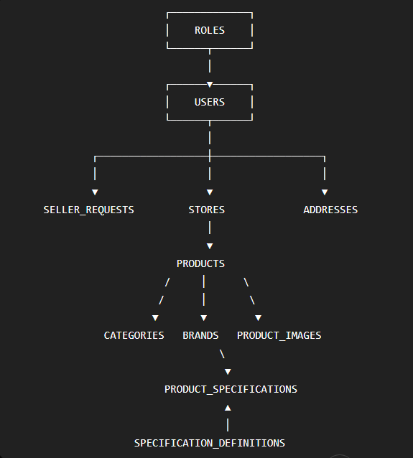
Then the customer side:
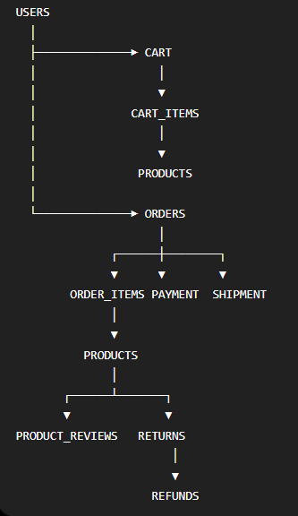
Team Member: Chou Yamata
Chan Punleur
Chem Sombok
Try Leangsreng
Topic : Computer Store Marketplace
Subject : Java III

